**NEW QUESTIONS**

* Is time important in egg weight trends? Important to know whether we should randomize or change from time to time the hour of day we measure eggs at each tower.
  + no apparent effect for all eggs or just looking at the first egg
* Certainty of order. We have measured some eggs with certainty of their order/place in the clutch, there are eggs that we don’t know whether they were second, third, etc. Use eggs that we are certain of to do analysis.
  + done, same results
* Compare difference between 1st and last egg (use 5th as a norm). Is there difference in weight, volume, density?
  + For the following model, lower AIC values for linear Julian or no Julian dates. Second egg is significantly lighter and smaller when no dates included. Second egg is marginally smaller when dates included.
  + I don’t know if I am doing density analyses right.
  + lmer(pes ~ egg_order2 + julian + I(julian^2) + (1|idCaixaNiu) + (1|idEstructura), data = Jackou_certain)
* Greater nest synchrony may lead to lighter and smaller eggs. However, this may need from some other more complex models to confirm…
* Tradeoff between egg size and clutch size? Does this depend on laying date? OR on egg laying order? Parent body condition?
  + Birds that lay larger clutches also lay larger and heavier eggs, but these variables decrease with laying date.
  + However, first eggs are bigger and heavier, and although the interaction with clutch size is significant, the AIC values show that the model without interaction is a better fit to our data.
* Does the number of nests (number of couples) within each tower affect weight, volume and density of eggs?
  + Colony size does not affect weight or volume of eggs, but Colony size may affect synchrony of laying. With this last analysis, we see a tendency to greater synchrony with larger colony sizes. Maybe another test would be nice.
* Model with varying slopes 🡪 compare with and without interaction (with tower) 🡪 AIC
  + The following model has a lower AIC value than models without quadratic Julian, without interaction with structure or with NestID as a random factor.
  + lmer(log10(pes) ~ log10(volum_ou)*idEstructura + julian +I(julian^2) + (1|idEstructura), data = Jackou_certain)
* Control for time of measurement.
  + Time at which eggs were measured does not seem to affect the weight, so I guess there is no significant effect of the time of day we measure the eggs

**The quality-quantity trade-off in heterogenous environments**

A crucial trade-off organisms encounter involves balancing quantity and quality in offspring: organisms that heavily invest in offspring typically have fewer offspring, while those that invest less tend to produce higher numbers of offspring of lower quality. In birds, offspring quality is largely determined by the size of the egg. Larger eggs tend to have higher hatching success rates and to yield nestlings with better chances of survival. However, in environments where energy resources are limited, allocating resources to produce larger eggs may come at the expense of reducing clutch size.

In uncertain or variable environments where the risk of reproductive failure is elevated, individuals may also adopt bet-hedging strategies to mitigate risk. One such strategy involves spreading reproductive effort across multiple events rather than concentrating it into fewer events. For example, individuals may reduce clutch size to increase the number of breeding attempts, thereby increasing their lifetime reproductive success (conservative bet-hedging). Alternatively, individuals may enhance variation in clutch size (diversified bet-hedging), increasing the likelihood that at least some offspring will survive in unpredictable environmental conditions.

Thus, the effectiveness of the quality-quantity trade-off can vary with environmental conditions. What may be adaptive in one environment could be maladaptive in another. Therefore, understanding the adaptive nature of these reproductive strategies requires evaluating how egg size, clutch size, and variation in egg size influence offspring growth and survival under different environmental circumstances, such as variations in temperature within and outside the nest, as well as prey availability.

Here, we investigate the adaptive significance of these reproductive strategies in jackdaws, aiming to elucidate how egg size, clutch size, and egg size variation impact offspring fitness under divergent environmental conditions. We predict a trade-off between egg size and clutch size, especially in environments where prey abundance (grasshoppers) is lower. We also tested whether the trade-off is less accentuated when parents are larger (big cars, big houses effect). Finally, we tested whether variation in egg size and clutch size depends on laying date. This is to be expected if early breeders are of better quality. Alternatively, selection may favour larger eggs in later breeders. By examining the interplay between reproductive traits and environmental factors, we aim to uncover the evolutionary mechanisms shaping avian reproductive strategies and their implications for offspring success and population dynamics.

**Orthopter abundance**

* Orth ~ Phen + (1|Tower) : More orth when phonologic stage includes flowers and seeds.
* Orth ~ period + (1|Tower): more orth during periods c and d

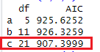It does seem to interact with time of the day.

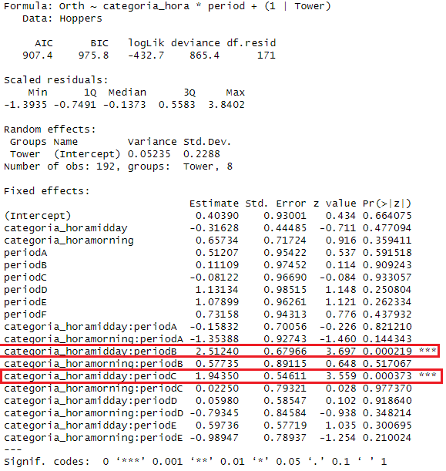

If joining periods into 20 day periods, b+c are joined together and it also results that this period at midday there is more arthropod abundance.

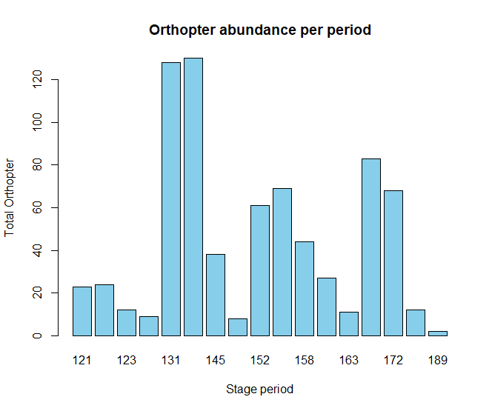

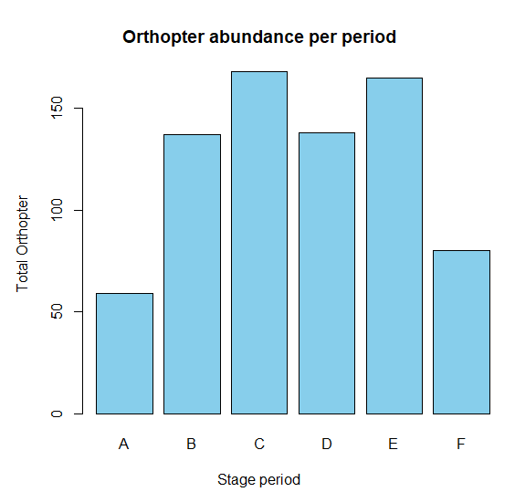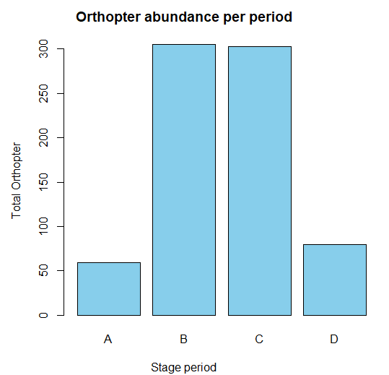

* Orth ~ Phen + period + (1|Tower) : probable correlation between time of the year and phenological stage of plants

Wild yields more tax groups: Ant, Dip and Orth. No harvest is important to presence of Ants.

**Egg weight relation to volume**

Weight of the egg as a response – size as a predictor. Random nest id + tower id.

* + Only randomizing nest 🡪 21% variació a nivel de Caixa niu
  + Only randomizing tower 🡪 3.8% variació a nivel de estructura
  + Randomizing both 🡪 tower id has 0.0% variation.
  + Randomizing nest id nested within tower id does not make sense as nest id is already identified by tower id.

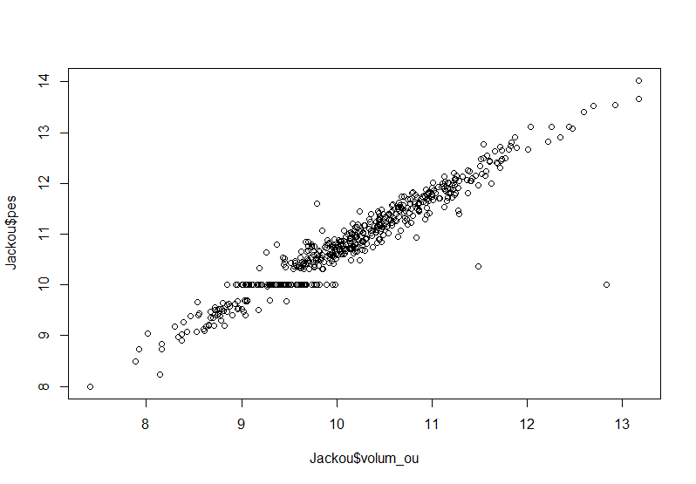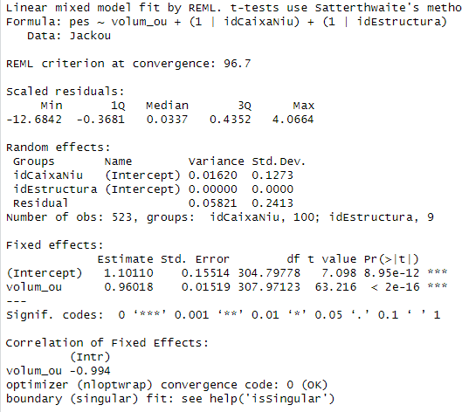

Laying date (fixed) – does condition depend on date?

* Slightly, but the nest id explains much more.

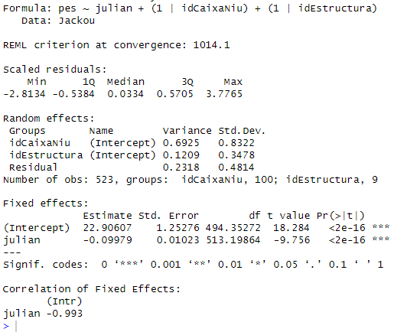

ARE THERE DIFFERENCES BETWEEN TOWERS?

* 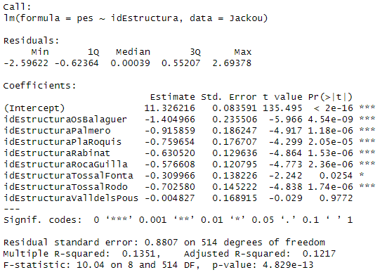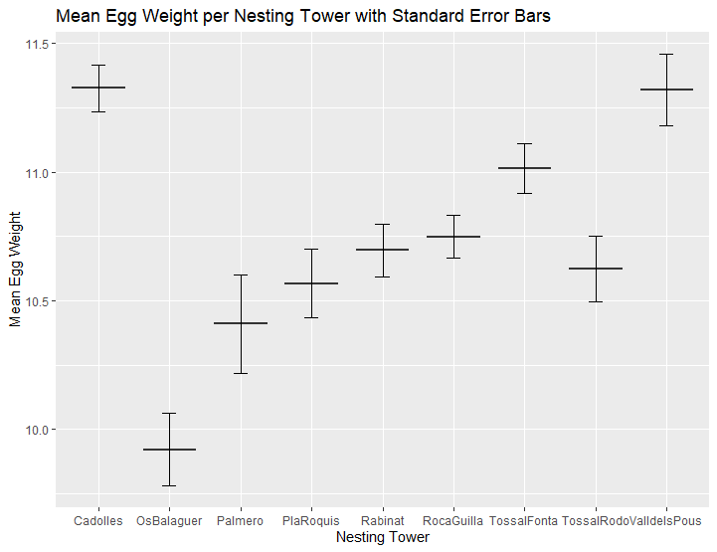Cadolles has heavier eggs than the rest of towers, but ValldelsPous
* Does volume also vary between towers? And density?
  + It seems that although volume of eggs is similarly different between towers compared to the weight, egg density is highest in palmero and valldelspous, suggesting that cadolles although big and heavy it keeps a relationship, while palmero has heavier eggs for the volume that is measured.

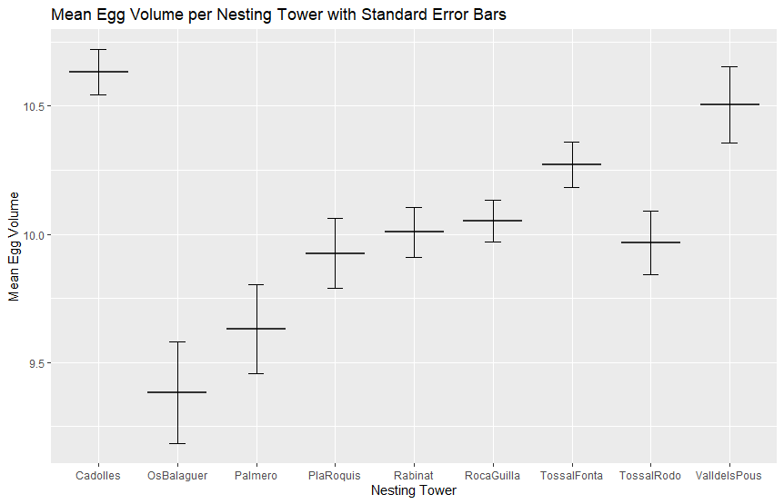

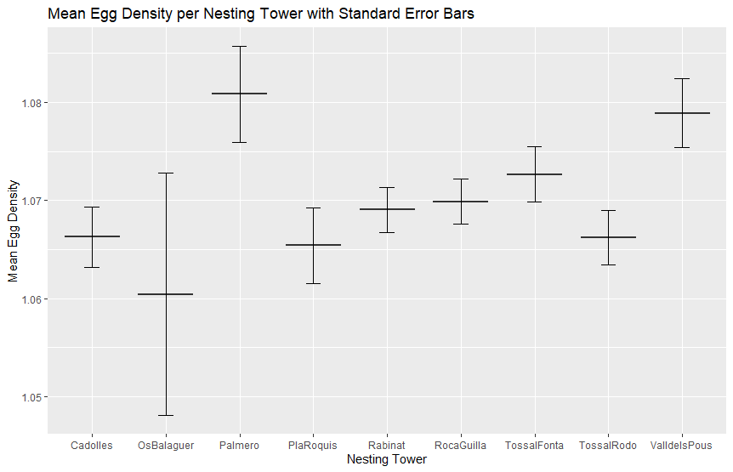

Is time an important factor to consider when looking at weight differences?

* 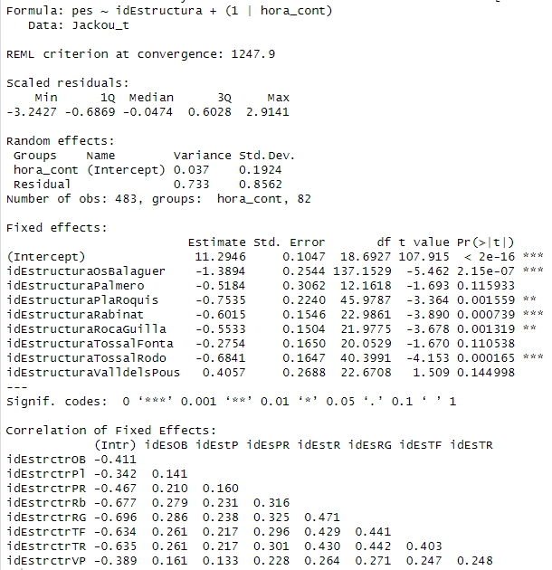Time does not seem to explain much of the variance… (4.8%)

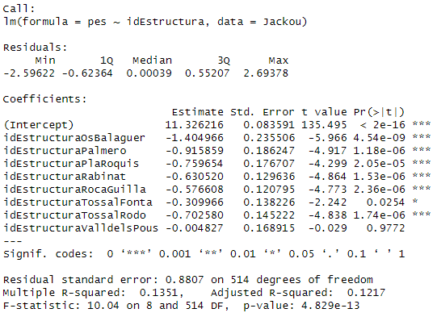

Time may not be an issue, but still the relationship between weight and volume seems to depend on the tower id.

* When using only first egg, the best fit still considers a linear Julian variable and the interaction.
* 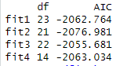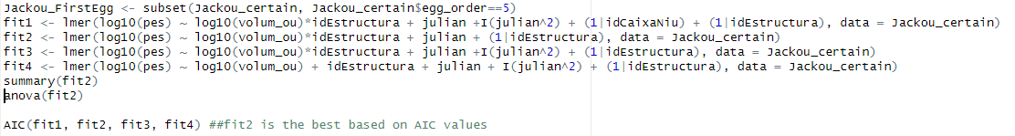However, when using only last egg, the best fit is the model without the interaction between volume and tower id and including the quadratic variable of laying date.

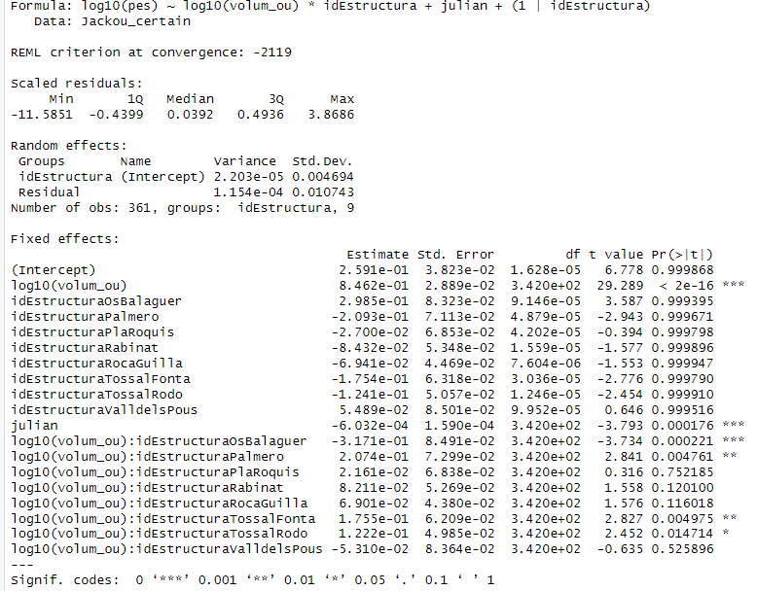

When categorizing the eggs between first and last, best models do not consider laying date to explain change in weight or volume, but still significant decrease in weight bewtween first and last egg.

Egg weight decreases with laying order in the majority of nests; however, it is just a trend of -0.14. Laying date seemed as it could explain part of this variation, but AIC values indicate that the better and most parsimonious fit would be without laying date as a predictor variable. Thus, this is probably due to some nests having opposite trends, but part of it could also be explained by laying date. Similar results for egg volume.

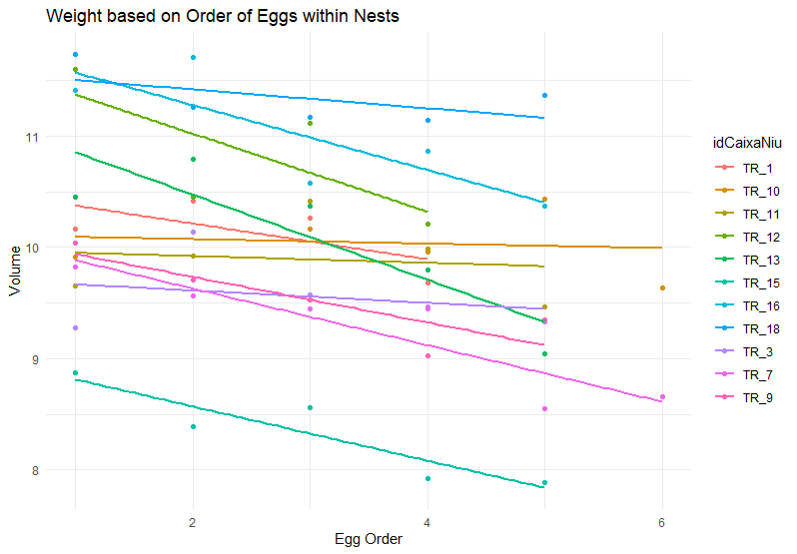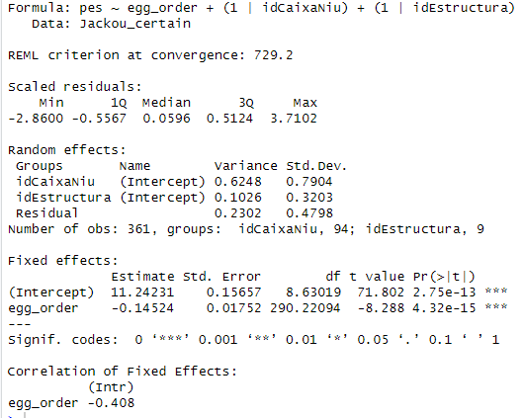

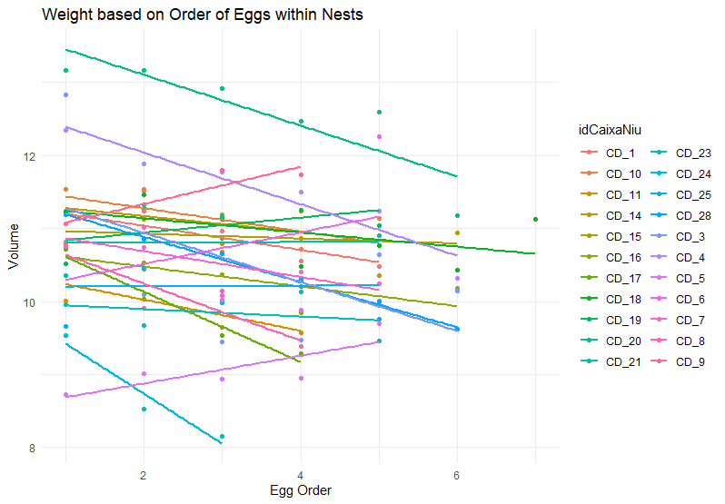

CONSIDERING CLUTCH SIZE.

We would expect that with increasing clutch size, egg volume and/or weight would decrease, as more eggs would require less investment per egg. Nevertheless, we see the contrary. After considering 3 models without laying date and with laying date in a linear and quadratic form, we see that the best fit is with the linear variable of the laying date. Egg weight increases with clutch size, but decreases with laying date. Same with volume. Same if we only consider the eggs we are certain of their laying date.

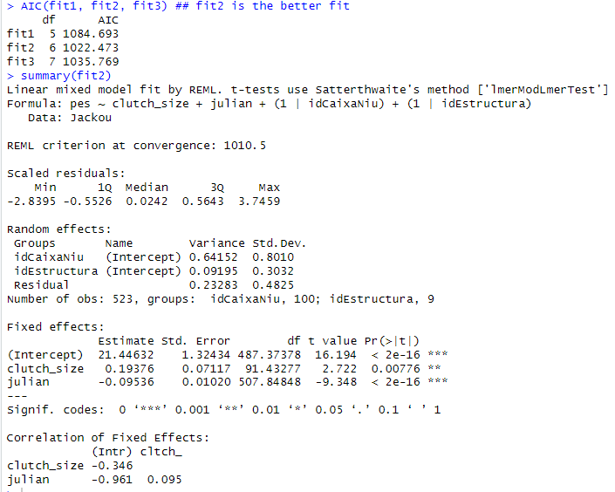

## does this depend on the egg_order? Whether the clutch size affects weight differently based on the order the egg was layed -- dont know how to test this.

Would this make sense?

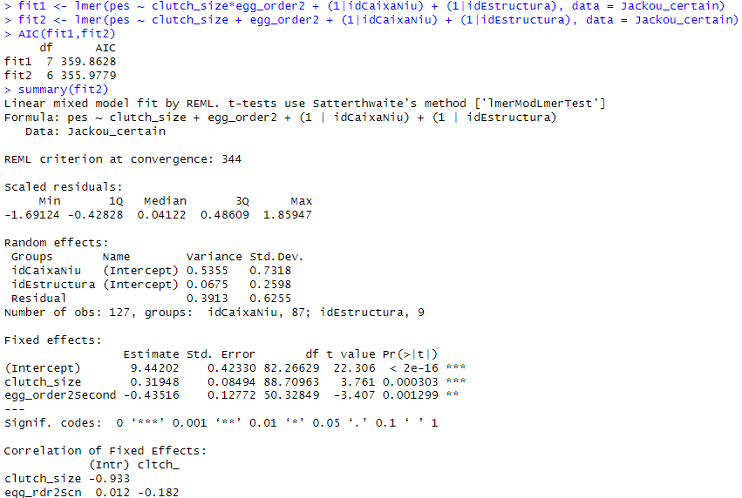

COLONY SIZE DOES NOT SEEM TO HAVE AN EFFECT ON WEIGHT OR VOLUME

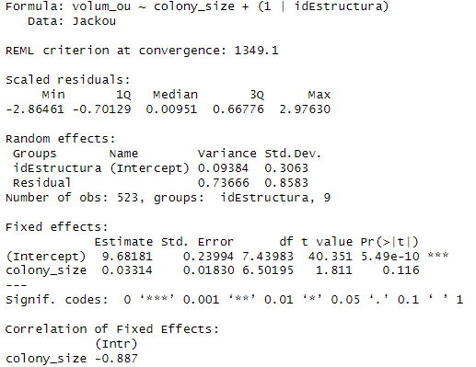

But does it affect synchrony of laying date? Yes, larger colonies seem to affect synchrony of laying date. Please discuss to see whether synchrony is calculated correctly.

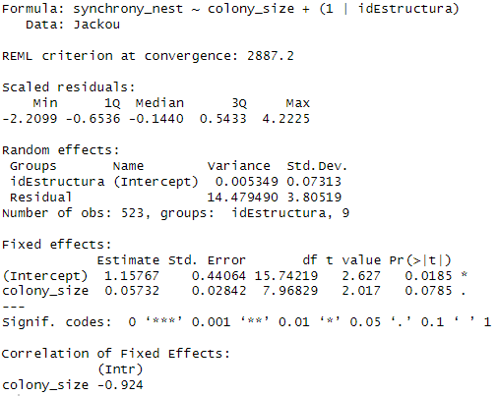

* Does weight/volume vary depending on synchrony? Of the tower members?
  + To do this we should use laying date and distance from mean laying date per tower?

WEIGHT ~ SYNCHRONY

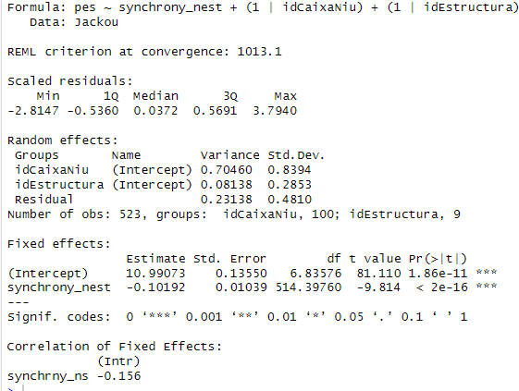

VOLUME ~ SYNCHRONY

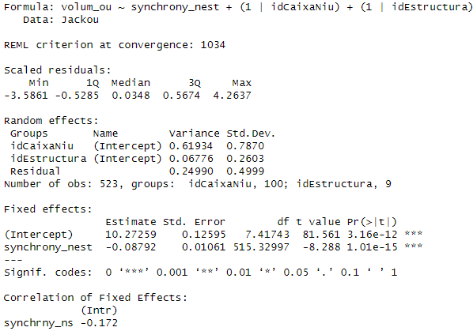

* how to codify nested random effects correctly?
* <https://www.muscardinus.be/statistics/nested.html>
* Validar si data de posta afecta. Quality of parents, laying date, distribution of nutrients/proteins/water per egg (depending on order)

Chicks’ growth appears to increase most between 7 and 14 days, being the first hatchling the heaviest throughout its growth.

